LAB - 10

|  |  |
| --- | --- |
| Name | Keval D Gandevia |
| Roll Number | CE046 |
| ID | 19CEUEG017 |
| Subject | Image Processing |

**Aim:** Perform following Image Restoration tasks.

**Q. 1: Add Uniform Noise into the image and plot histogram of noisy image. Use 'randi' function to generate uniformly distributed noise matrix.**

* **Code:**

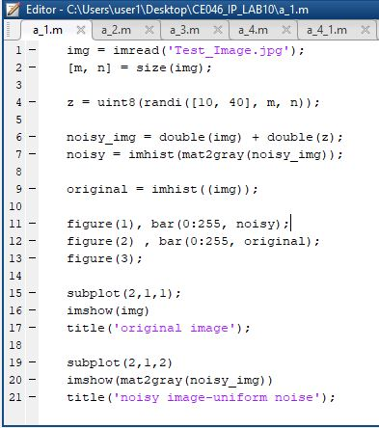

* 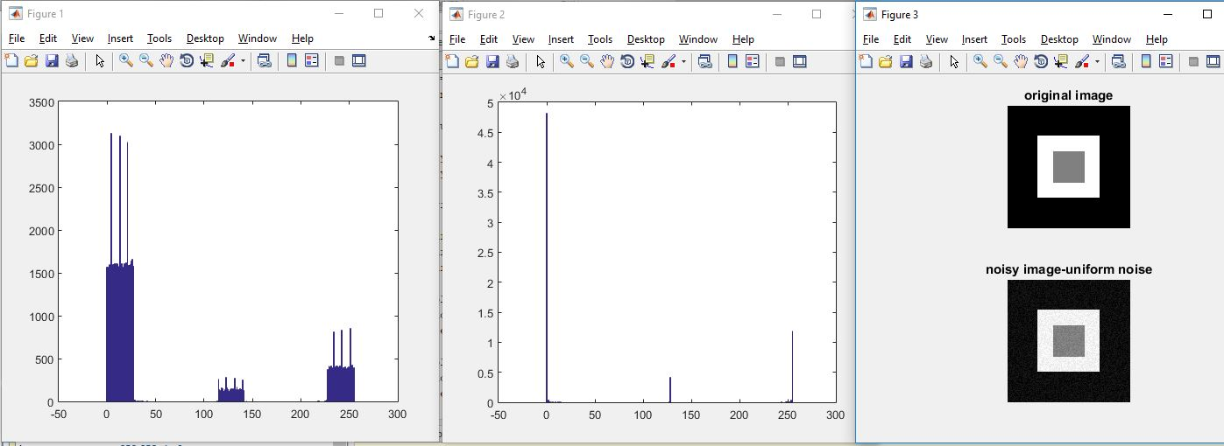**Output:**

**Q. 2: Add Gaussian (Normal) Noise into the image and plot histogram of noisy image. Use 'randn' function to generate Gaussian (Normal) distributed noise matrix with mean 1 and standard deviation 2.**

* 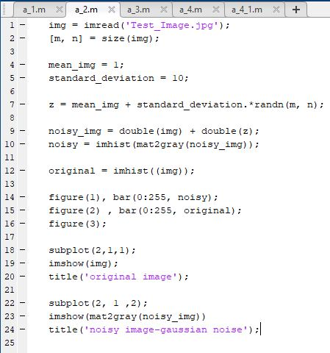**Code:**
* 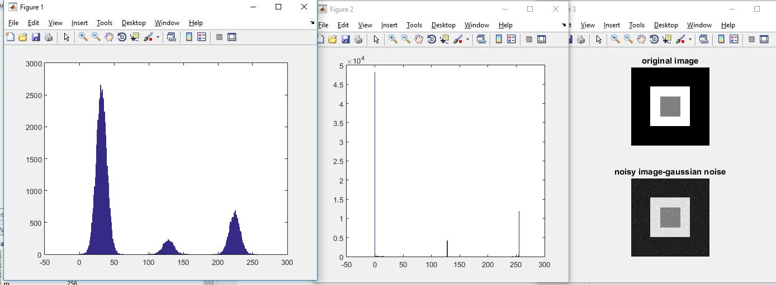**Output:**

**Q. 3: Using imnoise function to add 'Salt and Pepper' Noise.**

* **Code:**

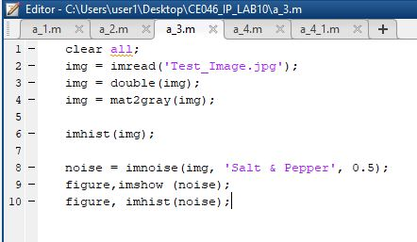

* **Output:**

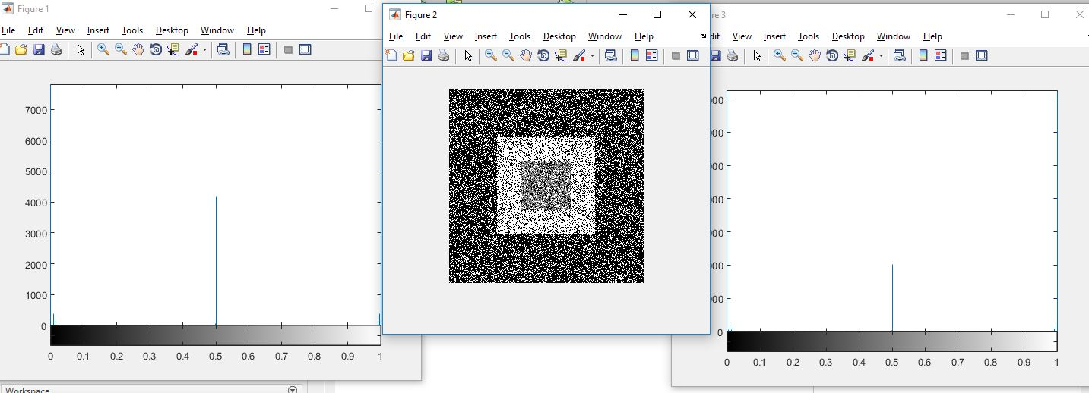

**Q. 4: Implement order statistics filters : Max, Min and Median. Compare your results with inbuilt function 'ordfilt2'.**

* 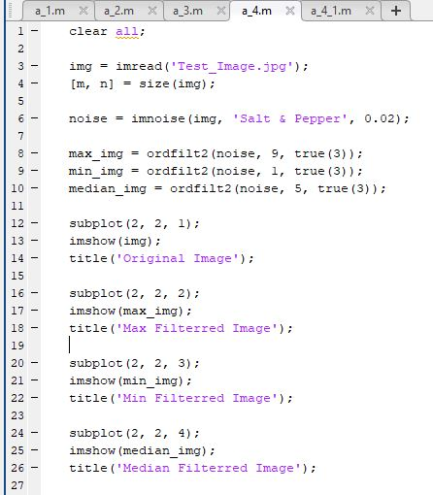**Code using ordflit2:**
* 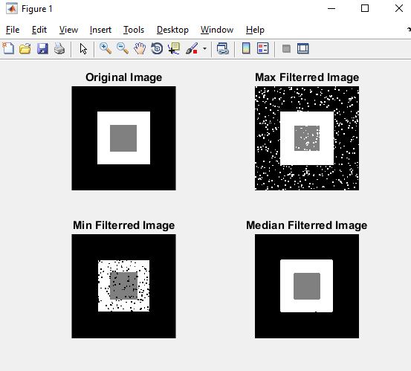**Output:**
* **Code using manual implementation:**

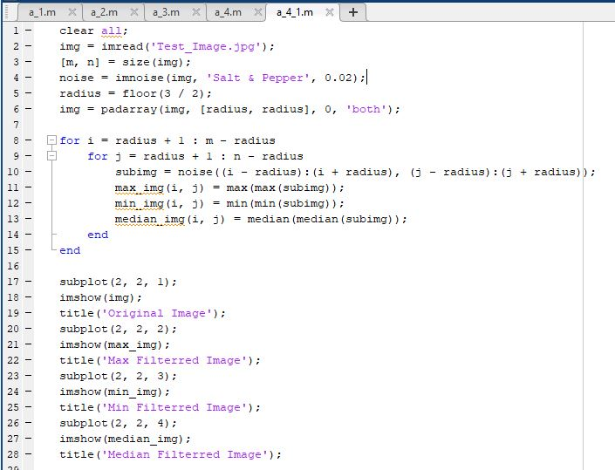

* **Output:**

